**LABCYCLE1**

**Submitted By**

**Anushree**

**S1 MCA**

**Roll No: 139**

**LABCYCLE 1**

**AIM:** Analyze CSS by applying the different styles using inline, external & internal style sheets in a HTML file

**PROGRAM CODE:**

|  |  |
| --- | --- |
| CO1-Q1  Inline CSS  CO1-Q1  External CSS | <!DOCTYPE html>  <html>  <head>  <title>Inline CSS</title>  </head>  <body bgcolor = "lightgreen">  <p style = "color:blue; font-size:50px;  font-style:serif; text-align:center;">  This is an example of inline CSS  </p>  </body>  </html>  <!DOCTYPE html>  <html>  <head>  <link rel="stylesheet" href="mystyle.css">  </head>  <body>  <h1>This is a heading</h1>  <p>This is a paragraph.</p>  </body>  </html> |

|  |  |
| --- | --- |
| CO1-Q1  Internal CSS | <!DOCTYPE html>  <html>  <head>  <style>  body {  background-color: lightyellow;  }  h1 {  color: maroon;  margin-left: 40px;  }  </style>  </head>  <body>  <h1>This is a heading.<br>  This comes under the internal css</h1>  <p>This is a paragraph</p>  </body>  </html> |

|  |  |
| --- | --- |
| Mystyle.css | body {  background-color: lightblue;  }  h1 {  color: navy;  margin-left: 40px;  } |

**RESULT:**

**Inline:**

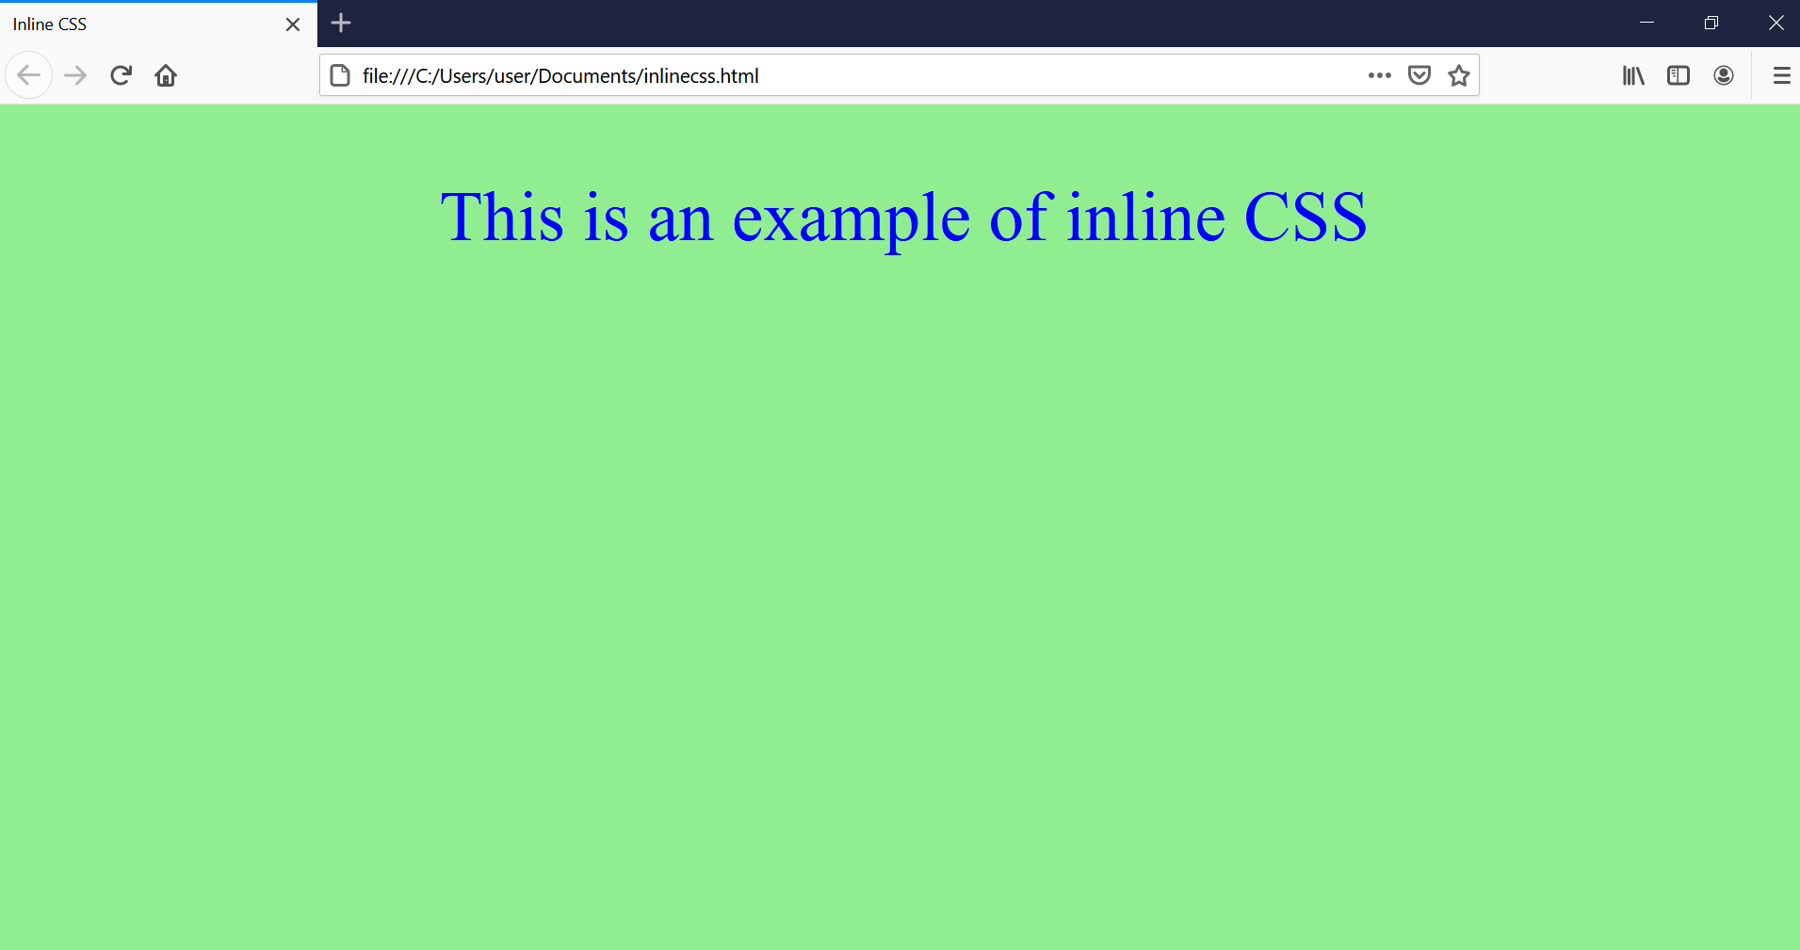

**Internal:**

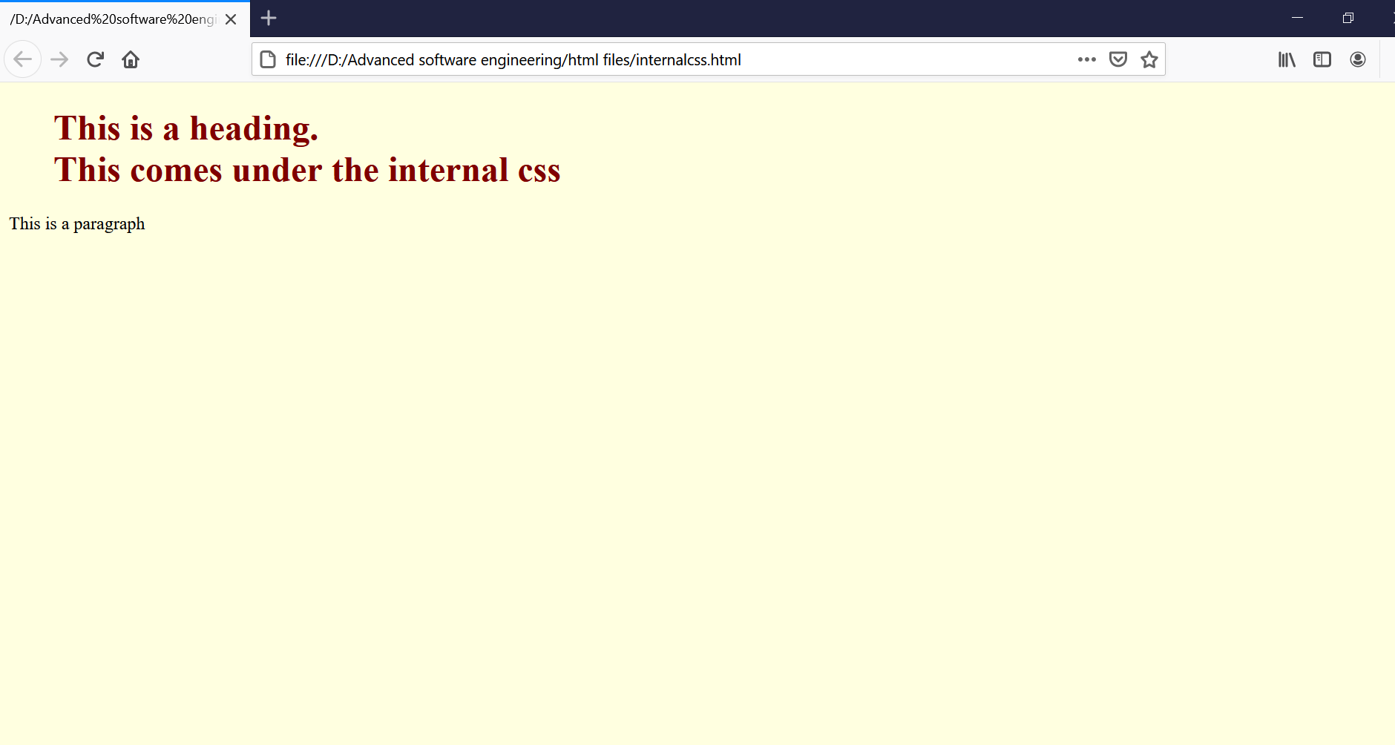

**External:**

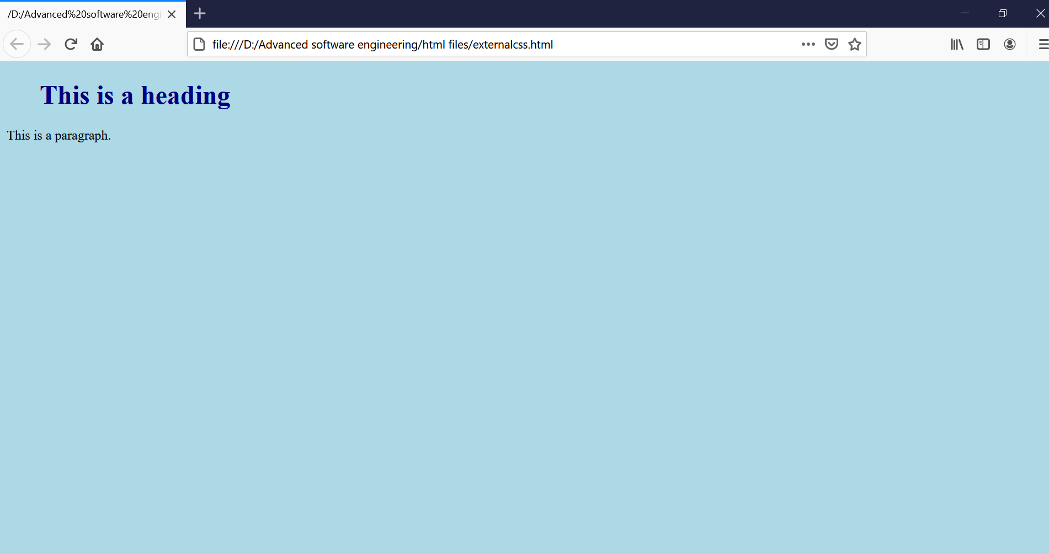

**LABCYCLE 1**

**AIM:** Demonstrate a registration form using HTML

**PROGRAM CODE:**

|  |  |
| --- | --- |
| CO1-Q2 | <!DOCTYPE html>  <html>  <head>  <title> Registration Form </title>  </head>  <body bgcolor = "lightpink">  <center>  <h2>REGISTRATION FORM</h2>  </center>  <form>  <label> Enter your Name : </label>  <input type = "text" name ="enter your name" size= "20"/> <br> <br>  <label> Enter your Age :</label>  <input type = "text" name ="enter your age" size ="10"/> <br><br>  <label> Enter your Address : </label>  <input type = "text" name ="enter your address" size ="30"/> <br><br>  <label> Gender: </label><br>  <input type="radio" name="male"/> Male <br>  <input type="radio" name="female"/> Female <br>  <input type="radio" name="other"/> Other  <br>  </body>  </html> |

**Result:**

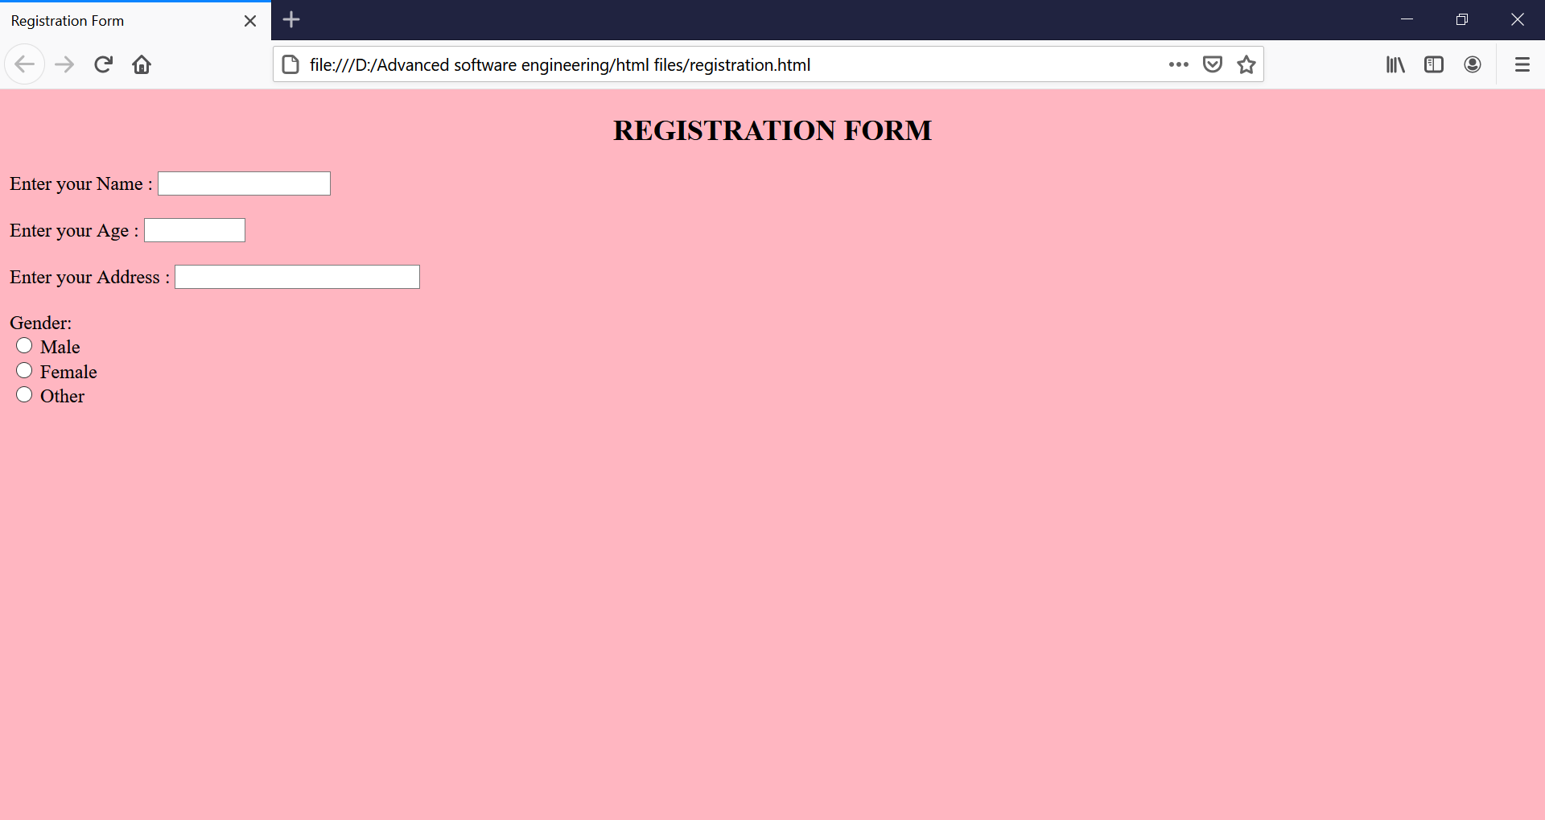

**LABCYCLE 1**

**AIM:** Model a simple HTML file to demonstrate the use of different tags.

**PROGRAM CODE:**

|  |  |
| --- | --- |
| CO1-Q3 | <html>  <head>  <title>Different tags in html  </title>  </head>  <body bgcolor = "pink">  <h1>This is heading 1</h1>  <h2>This is heading 2</h2>  <h3>This is heading 3</h3>  <h4>This is heading 4</h4>  <h5>This is heading 5</h5>  <h6>This is heading 6</h6>  <p>This is a paragraph.</p>  <img src="https://cache.careers360.mobi/media/presets/720X480/colleges/social-media/media-gallery/2187/2018/7/26/TKM-College-of-Engineering-Kollam-1.jpg" alt="tkmce_logo" width="900" height="800">  <br><br>  <a href="https://tkmce.ac.in/">This is a link</a><br><br>  <a href="http://www.caskozhikode.ihrd.ac.in/">Visit CAS-IHRD</a><br><br>  <table>  <tr>  <th>First Name</th>  <th>Age</th>  <th>Marks</th>  </tr>  <tr>  <td>Anu</td>  <td>21</td>  <td>100</td>  </tr>  <tr>  <td>Shree</td>  <td>22</td>  <td>94</td>  </tr>  </table>  <br>  <p>The following is an unordered list.</p>  <ul>  <li>Coffee</li>  <li>Tea</li>  <li>Milk</li>  </ul><br>  <p>The following is an ordered list.</p>  <ol>  <li>Coffee</li>  <li>Tea</li>  <li>Milk</li>  </ol>  <br>  <p>The following is an html description lists.</p>  <dl>  <dt>Coffee</dt>  <dd>- black hot drink</dd>  <dt>Milk</dt>  <dd>- white cold drink</dd>  </dl>  <br>  <div style="border: 1px solid black">The DIV element is a block element, and will always start on a new line and take up the full width available (stretches out to the left and right as far as it can).</div>  <br><br>  <form>  <label for="fname">First name:</label><br>  <input type="text" id="fname" name="fname"><br>  <label for="name">Last name:</label><br>  <input type="text" id="lname" name="lname">  </form>  <br>  <form>  <input type="radio" id="male" name="gender" value="male">  <label for="male">Male</label><br>  <input type="radio" id="female" name="gender" value="female">  <label for="female">Female</label><br>  <input type="radio" id="other" name="gender" value="other">  <label for="other">Other</label>  </form>    </body>  </html> |

**Result:**

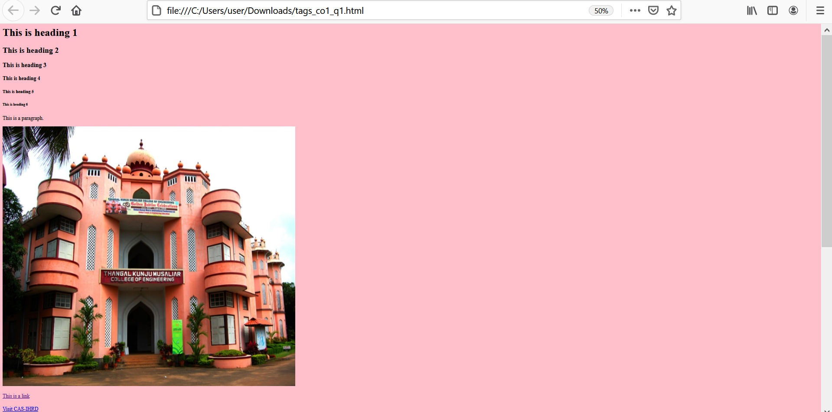

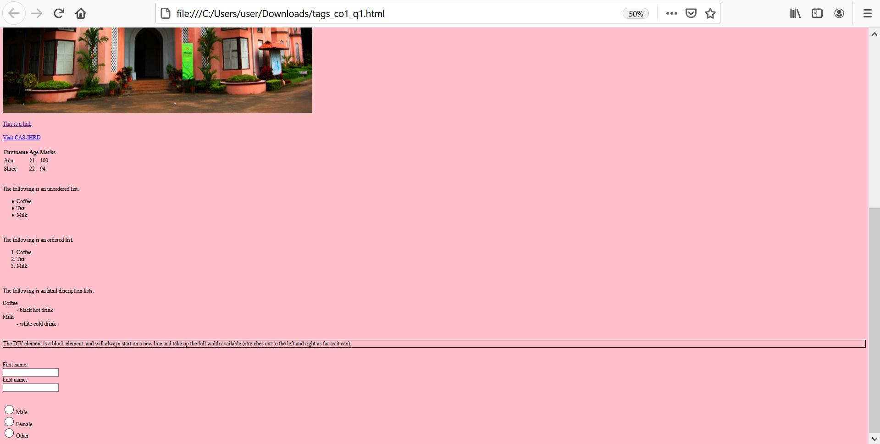

**LABCYCLE 1**

**AIM:** Create a HTML file to link to different HTML pages which contain images, tables, and also link within a page.

**PROGRAM CODE:**

|  |  |
| --- | --- |
| CO1-Q4  About Me | <!DOCTYPE html>  <html>  <head>  <title>About Me</title>  </head>  <body background="https://assets.awwwards.com/awards/images/2015/04/pattern.jpg">  <header>  <nav>  <ul>  <li><a href="file:///C:/Users/user/Documents/Anushreetp.html">HOME</a></li>  <li><a href="file:///C:/Users/user/Documents/marks.html">MARKS</a></li>  <li><a href="file:///C:/Users/user/Documents/contact.html">CONTACTS</a></li>  </ul>  </nav>  </header><hr>  <font color="blue">  <center>  <h2>HELLO,I'm Anushree</h2>  <h3>  I'm a MCA student studying at <a href="https://tkmce.ac.in/">TKM Kollam Kerala.</a>  I am Electronics graduate,graduated from <a href="http://caskozhikode.ihrd.ac.in/cas/">College of Applied Science Calicut-IHRD<br></a>  I am aiming to complete my postgraduate and become a part of a progressive organization where I can make use of my skills and capabilities.  I like writing,playing,dancing,some sketching,etc.</h3>  </center>  </body>  </html> |

|  |  |
| --- | --- |
| CO1-Q4  Contact Details | <!DOCTYPE html>  <html>  <head>  <title>Contact details</title>  </head>  <body background="https://assets.awwwards.com/awards/images/2015/04/pattern.jpg">  <center>  <h2><u>My contact details</u></h2>  <p> Address - Valappil Jetty Road Puthiyanirath Elathur Kozhikode Kerala</p><br>  Mobile- 8289940696<br>  Mobile- 8289941325<br>  Landline- 04952965825<br>  </center>  </body>  </html> |

|  |  |
| --- | --- |
| CO1-Q4  Marks | <!DOCTYPE html>  <html>  <head>  <title>Degree marks</title>  </head>  <body background="https://assets.awwwards.com/awards/images/2015/04/pattern.jpg">  <center>  <p>The marks that i obtained in the degree course are tabulated as follows:</p>  <font color="black">  <table border=1>  <tr>  <th>Subjects</th>  <th>Marks(out of 100)</th>  </tr>  <tr>  <td>English</td>  <td>76</td>  </tr>  <tr>  <td>Hindi</td>  <td>100</td>  </tr>  <tr>  <td>Other than Language</td>  <td>85</td>  </tr>  <tr>  <td>Core Course:Electronics</td>  <td>75</td>  </tr>  <tr>  <td>Complementary Course1:Mathematics</td>  <td>80</td>  </tr>  <tr>  <td>Complementary Course2:Computer Science</td>  <td>86</td>  </tr>  <tr>  <td>Open Course:Introduction to computer and Office Automation</td>  <td>65</td>  </tr>  </table>  </center>  </body>  </html> |

**Result:**

**About Me:**

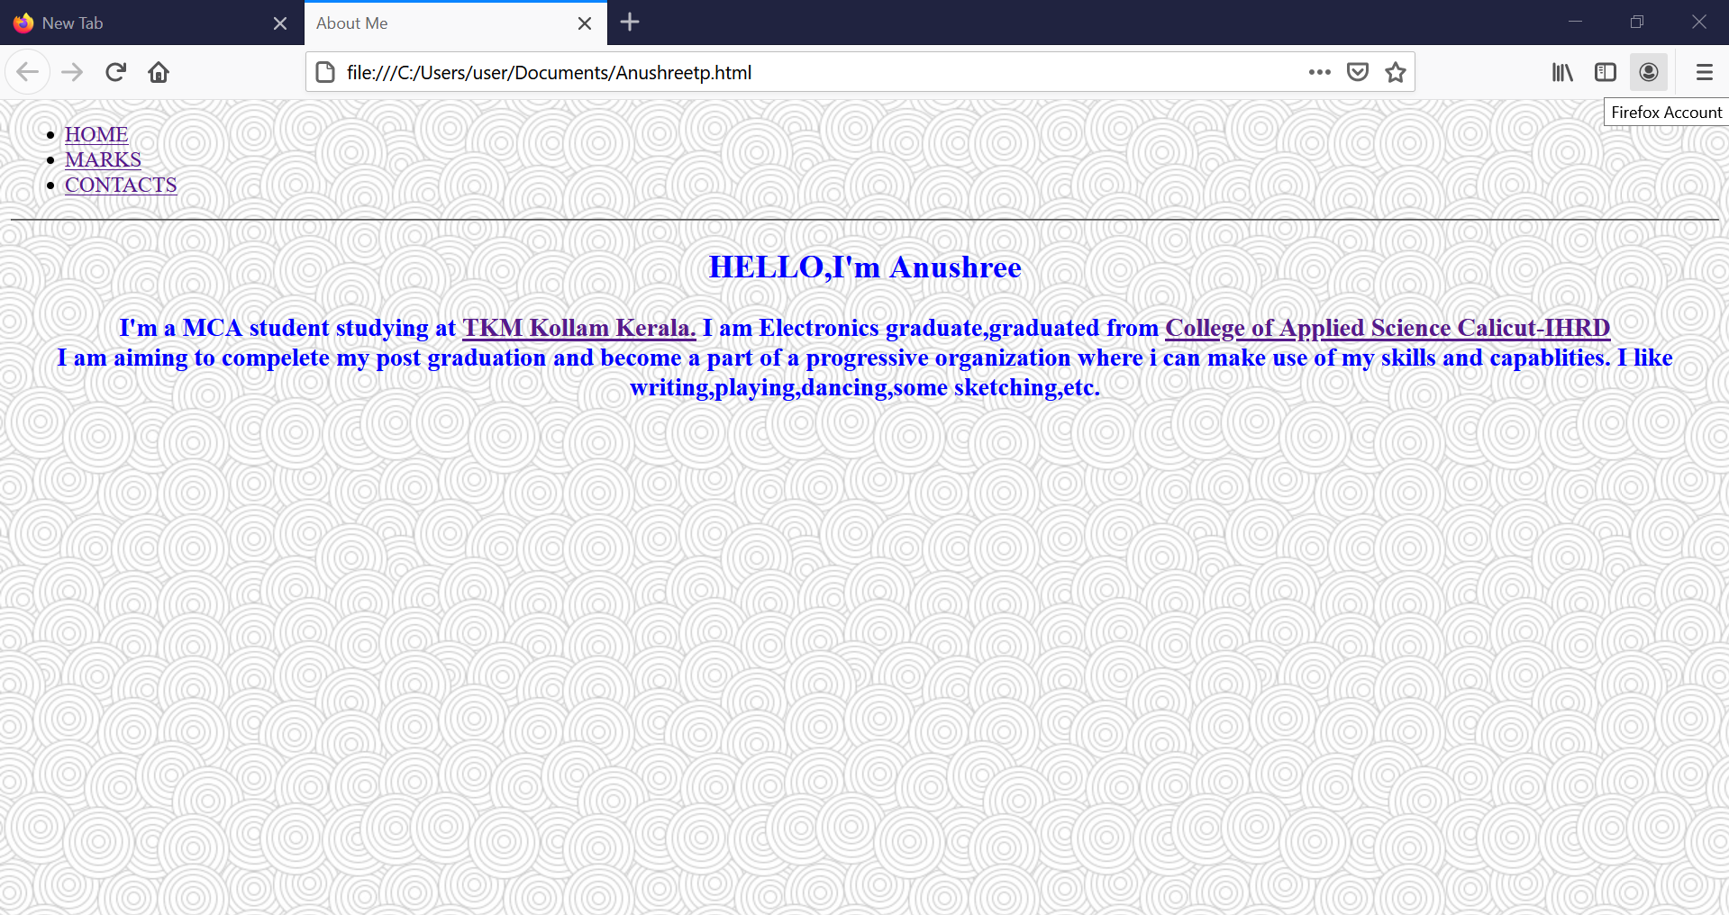

My contact:

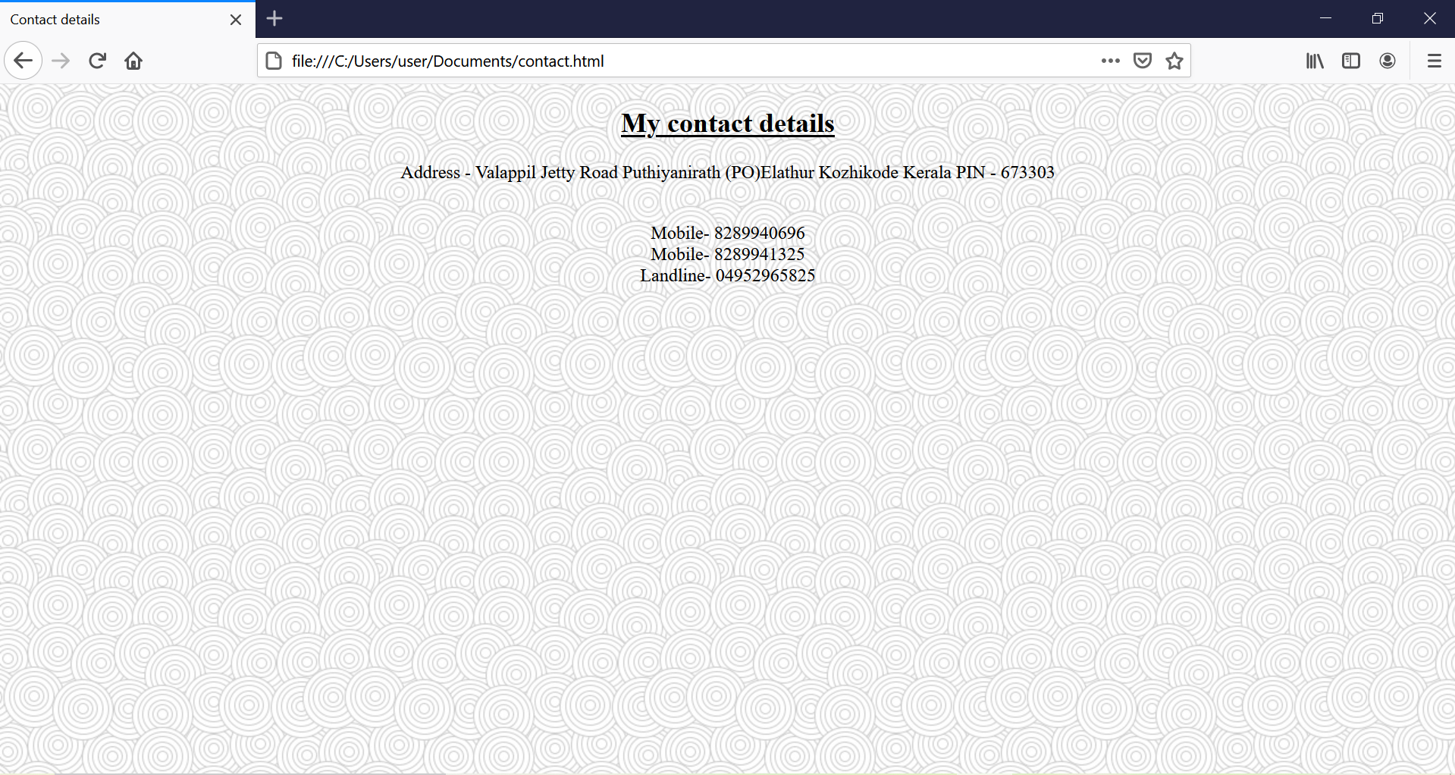

Marks:

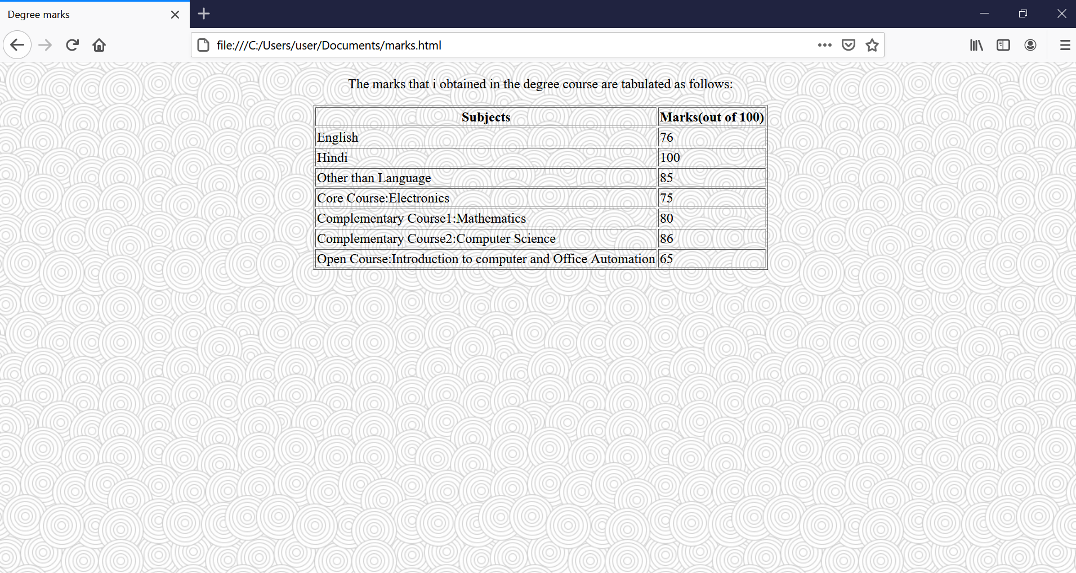

**LABCYCLE 1**

**AIM:** Create a HTML page with different types of frames such as floating frame, navigation frame & mixed frame.

|  |  |
| --- | --- |
| CO1-Q5  Floating Frame  CO1-Q5  Navigation menu | <!DOCTYPE html>  <html>  <head>  <title>Floating Frame  </title>  </head>  <body>  <iframe src="https://tkmce.ac.in/" width="500px" height="400px"></iframe>  </body>  </html>  <!DOCTYPE html>  <html>  <body bgcolor = "lightyellow">  <a href = "https://tkmce.ac.in/" target = "main_page">TKMCE,Kollam</a>  <br />  <br />    <a href = "http://caskozhikode.ihrd.ac.in/cas/" target = "main_page">CAS IHRD Calicut</a>  <br />  <br />    <a href = "http://gectcr.ac.in/" target = "main_page">EC,Thrissur</a>  </body>    </html> |

|  |  |
| --- | --- |
| CO1-Q5  2)Navigation body  CO1-Q5  3)Navigation Frame  C01-Q5  Mixed Frame | <!DOCTYPE html>  <html>  <head>  <title>Navigation Body</title>  </head>  <body bgcolor = "lightblue">  <h3>This is main page and content from any link will be displayed here.</h3>  <p>So now click any link and see the result.</p>  </body>    </html>  <!DOCTYPE html>  <html>  <head>  <title>Navigation Frame</title>  </head>    <frameset cols = "300, *">  <frame src = "navi_menu.html" name = "menu_page" />  <frame src = "navi_body.html" name = "main_page" />    <noframes>  <body>Your browser does not support frames.</body>  </noframes>  </frameset>    </html>  <!DOCTYPE html>  <html>  <head>  <title>Mixed Frames</title>  </head>    <frameset cols = "25%,25%,25%,25%">  <frame name = "top" src = "https://tkmce.ac.in/" />  <frame name = "main" src = "http://caskozhikode.ihrd.ac.in/cas/" />  <frame name = "bottom" src = "https://timesofindia.indiatimes.com/" />  <frameset rows = "50%,50%">  <frame name = "top" src = "https://tkmce.ac.in/" />  <frame name = "main" src = "http://caskozhikode.ihrd.ac.in/cas/" />  </frameset>    <noframes>  <body>Your browser does not support frames.</body>  </noframes>    </frameset>    </html> |

**Result:**

Floating Frame:

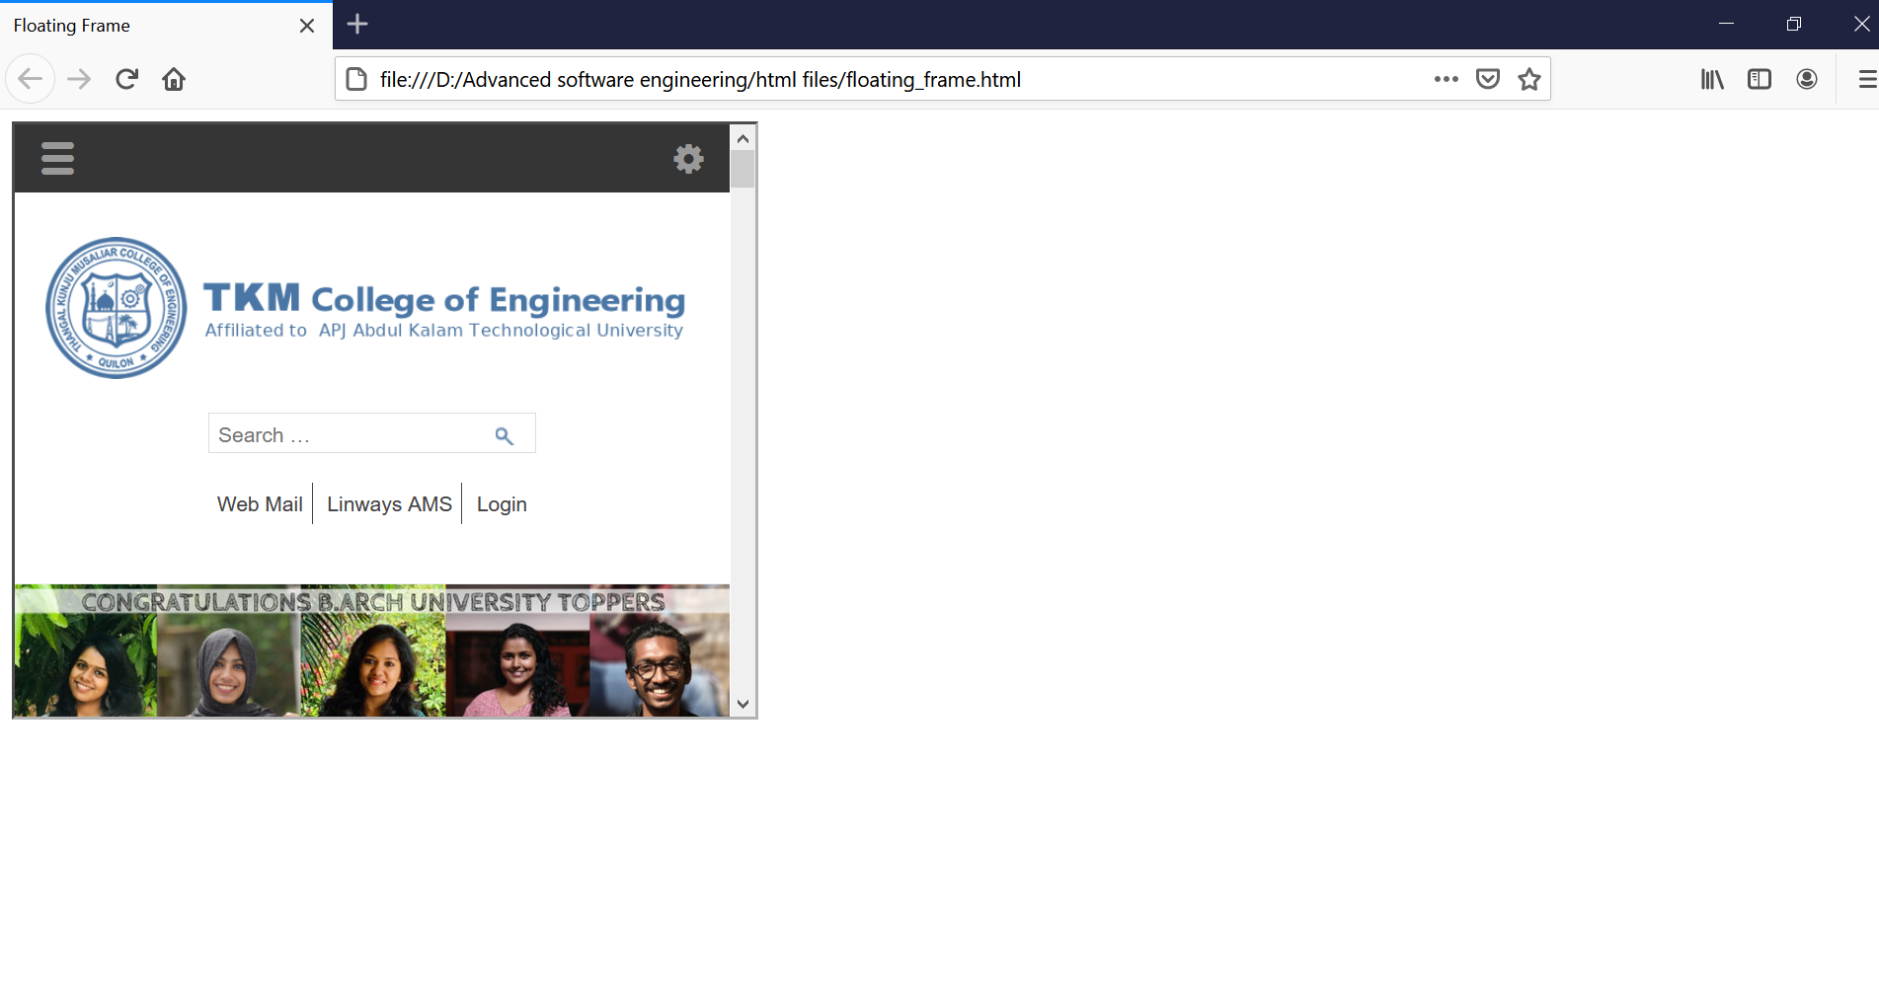

Navigation Frame:

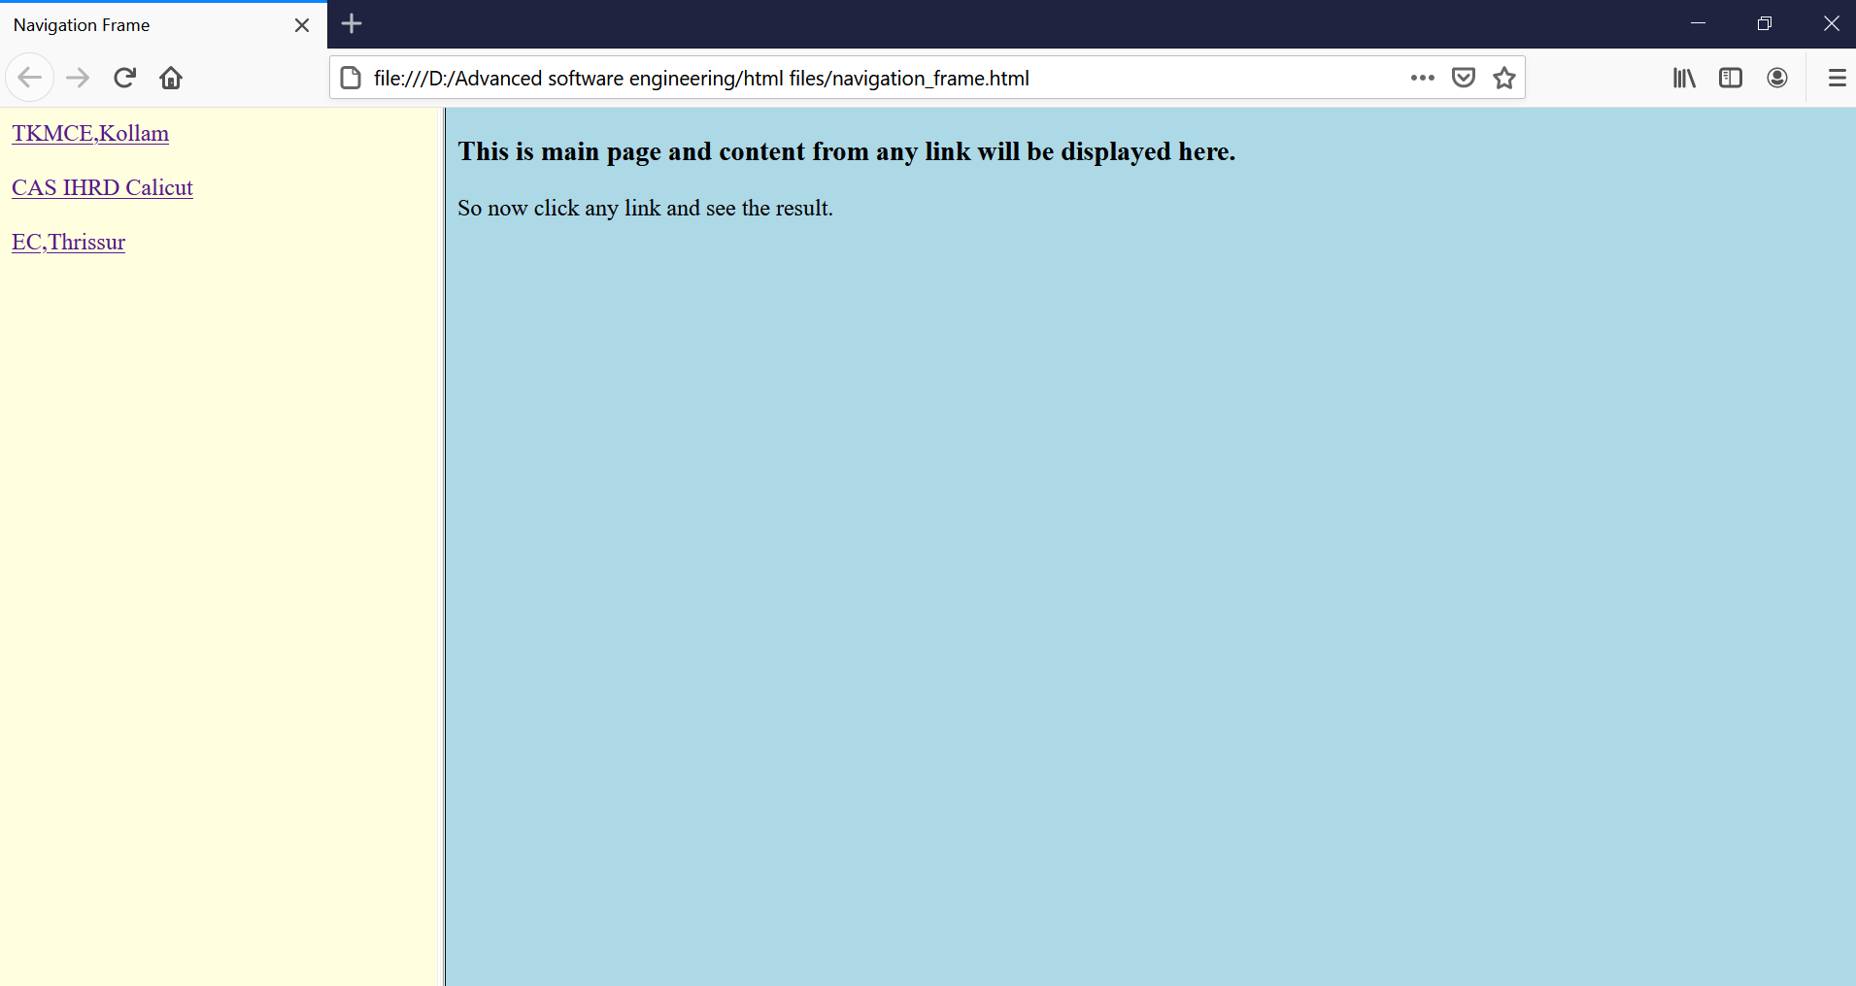

Navigation Menu:

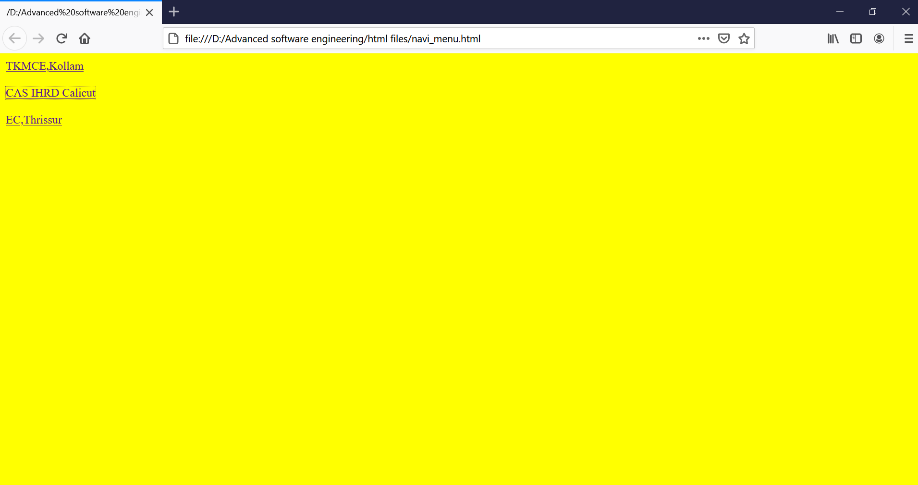

Navigation body:

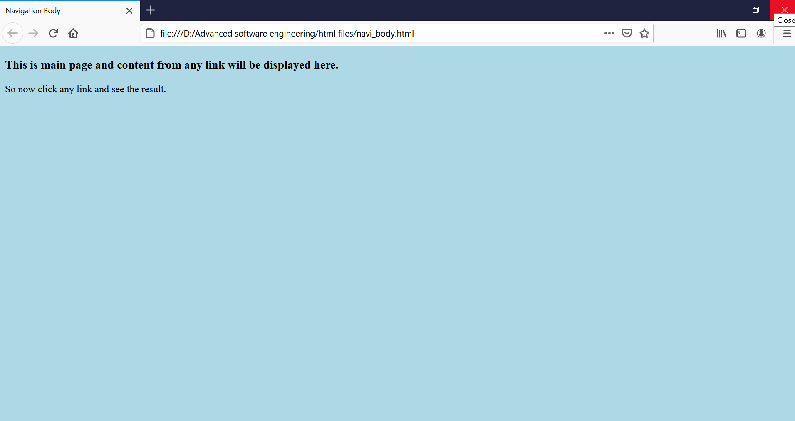

Mixed Frame:

